Session 2026-2027

Session | 2024-25 (ODD) |  | Course Name | Web Technology Lab
Semester | 3 |  | Course Code | 23CT1301
Roll No | A-11 |  | Name of Student | Gargi Vinod More
Practical Number
Course Outcome |  | - Understand various internet technologies.  - Design the web pages using HTML and CSS.  - Implement the XML technology to store the data.  - Develop the interactive web pages using JavaScript.
Aim |  | To design a registration form using HTML and implement JavaScript conditional statements, loops, and form validation to validate the user's name, email, password, and phone number on form submission, with inline error messages.
Problem Definition |  | Create a registration form containing fields for Name, Email, Password, and Phone Number. Write JavaScript code to validate each field when the user submits the form. The program should check whether the fields are empty and whether the entered data follows the required format. If any input is invalid, an appropriate error message should be displayed next to that field. The form should be submitted only when all the entered information is valid.
Theory  (100 words) |  | JavaScript is a scripting language used to make web pages interactive and dynamic. Conditional statements such as if, else if, and else are used to make decisions based on conditions. Loops such as for and while are used to repeat a set of statements. Form validation checks whether information entered by a user is correct before submission. JavaScript can validate required fields, email format, password length, and phone number format. The Document Object Model (DOM) allows JavaScript to access and modify HTML elements. Error messages can be displayed dynamically beside input fields. Client-side validation improves usability and helps prevent incorrect data from being submitted.
Procedure and Execution  (100 Words) |  | Step for Implementation:  Create an HTML document using a text editor.  Add a registration form containing Name, Email, Password, and Phone Number fields.  Create separate elements near each input field to display error messages.  Add a Submit button to the form.  Write JavaScript code to access the form and its input elements using DOM methods.  Use conditional statements to check whether each field is empty or contains invalid data.  Use regular expressions to validate email and phone number formats.  Check the password length using a conditional statement.  Display an appropriate inline error message for every invalid field.  Prevent form submission if any validation fails.  Display a success message when all fields contain valid information.  Open the HTML file in a browser and test different inputs.
 |  | Code: 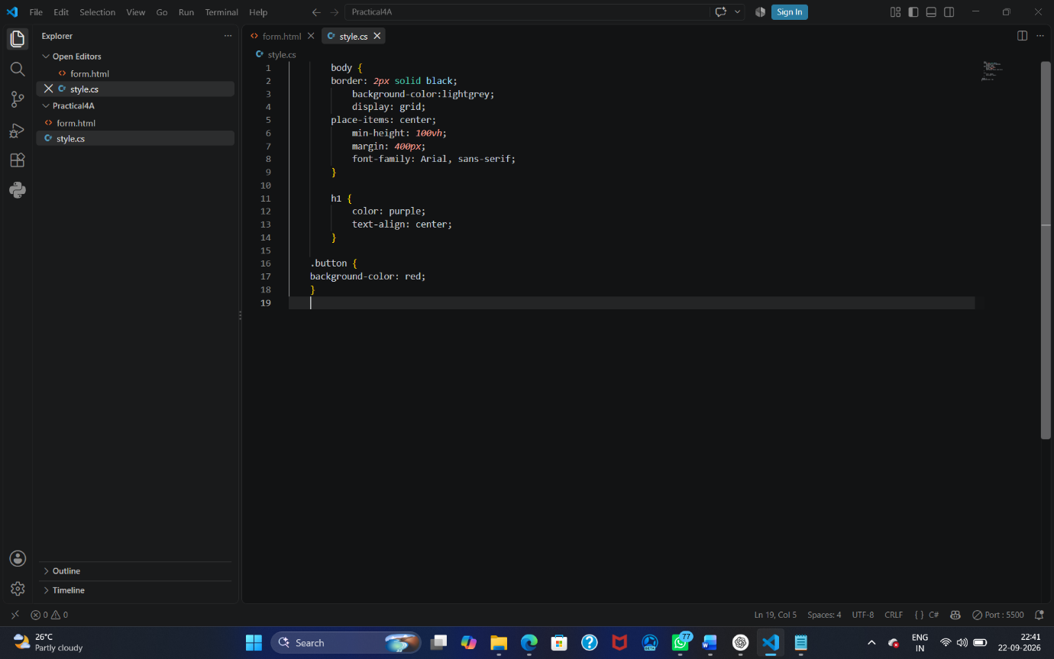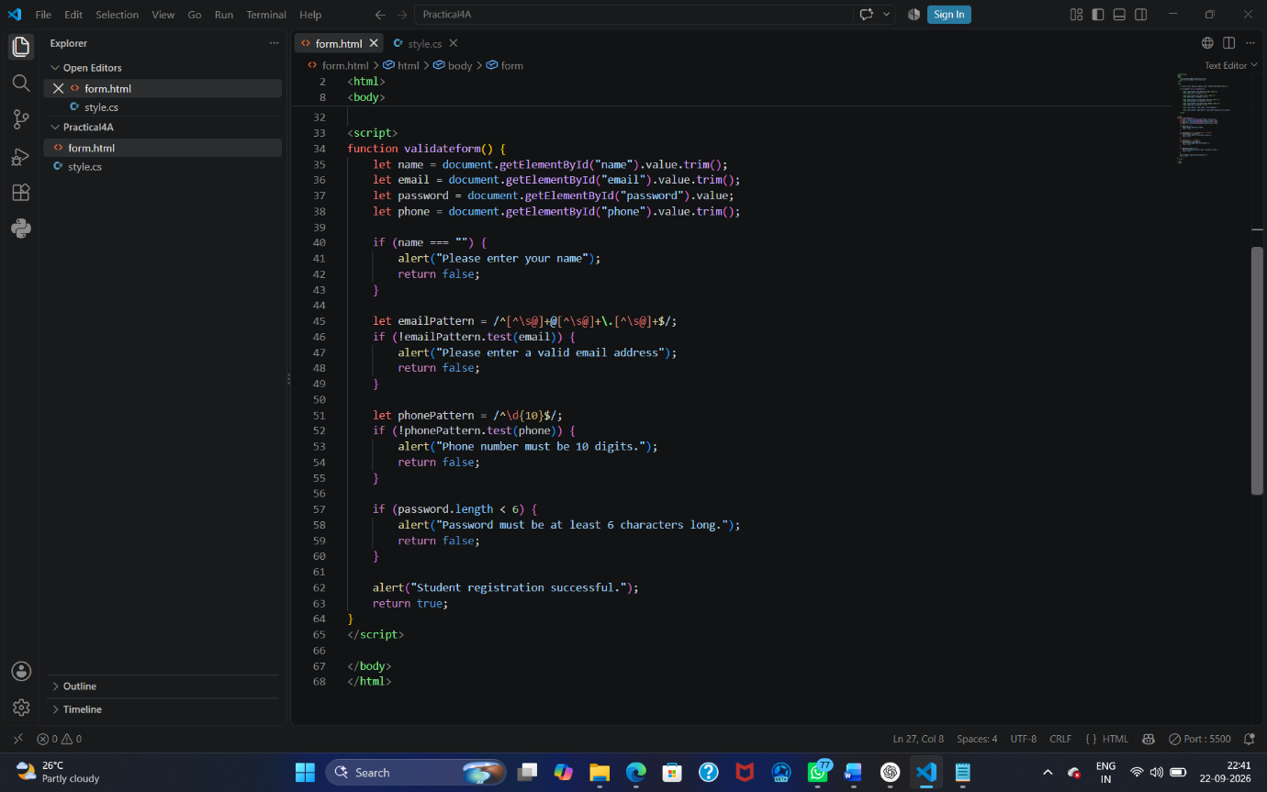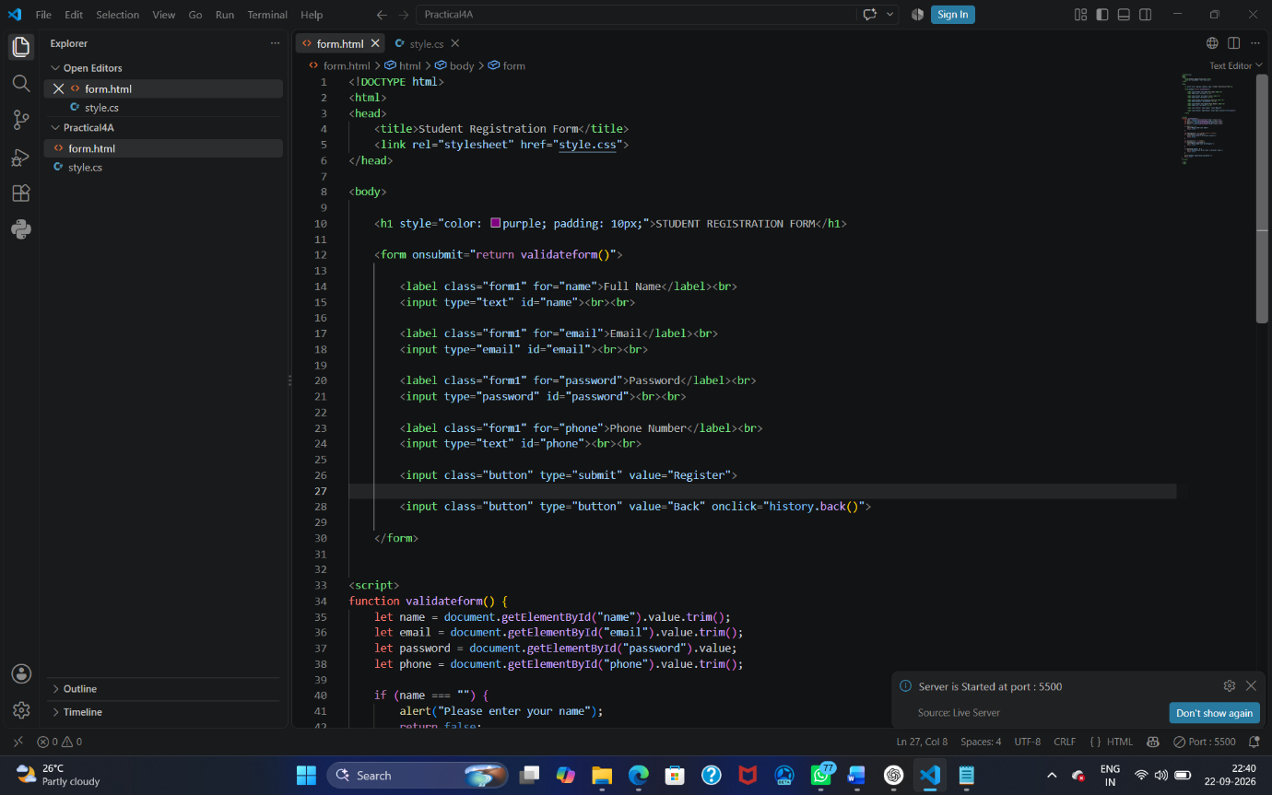
 |  | Output: 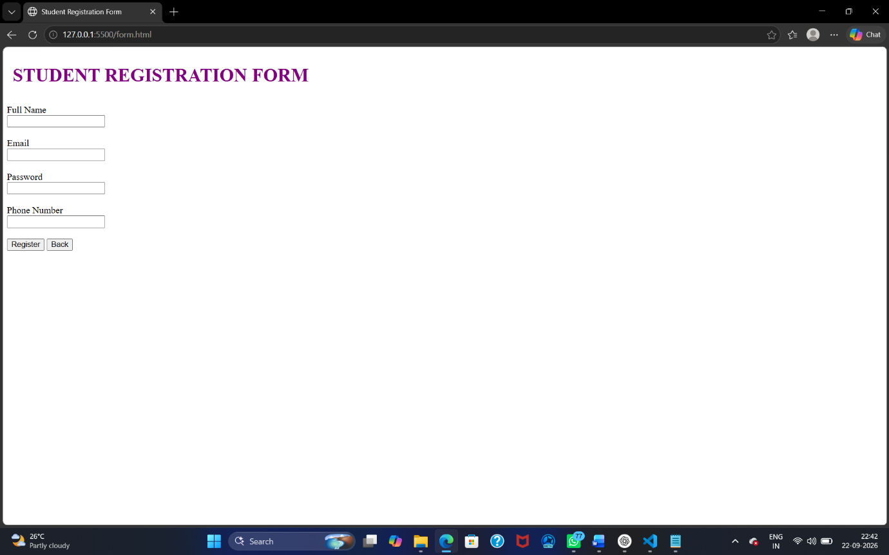
Output Analysis |  | The registration form successfully accepts Name, Email, Password, and Phone Number as input. When the Submit button is clicked, JavaScript checks each field. Empty or incorrectly formatted fields produce inline error messages beside the respective input boxes. A valid email must follow the required email pattern, while the password must satisfy the specified minimum length. The phone number is checked for the required number format. When all fields are valid, the validation errors are removed and a success message is displayed. Thus, JavaScript conditional statements and form-validation techniques work together to prevent invalid information from being submitted.
Link of student Github profile where lab assignment has been uploaded
Conclusion |  | The registration form was successfully developed using HTML and JavaScript. JavaScript conditional statements were used to check different validation conditions, while form validation ensured that the entered information followed the required format. Inline error messages made it easy for users to identify and correct invalid fields. This practical demonstrates how JavaScript can be used to create interactive and user-friendly web forms.
Plag Report (Similarity index < 12%) |  | The report content has been written in original wording and structured specifically for this practical.
Date |  | 22/09/2026

